**Name: Vikas Mane**

**Roll No: B1921152**

**Class: BE-B**

Virtual Lab Assignment

**Problem Statement:** Introduction to Fundamental of Fuzzy Logic and Basic Operations

**Objective:** To perform Fuzzy Logic Operations such as Addition, Subtraction, Complement, Union & Intersection

# Theory:

**Fuzzy Sets:**

* A fuzzy set is a pair (A,m) where A is a set and m : A -->[0,1].
* For each x ε A, m(x) is called the grade of membership of x in (A,m). For a finite set A =

{x1,...,xn}, the fuzzy set (A,m) is often denoted by {m(x1) / x1,...,m(xn) / xn}.

* Let x ε A. Then x is called not included in the fuzzy set (A,m) if m(x) = 0, x is called fully included if m(x) = 1, and x is called a fuzzy member if 0 < m(x) < 1.The set { x ε A | m(x) > 0 } is called the support of (A,m) and the set { x ε A | m(x) =1 } is called its kernel.

# Fuzzy Set Operations:

**Fuzzy Addition**

Let us consider A1 = [a,b] and A2 = [c,d]

The addition of A1 and A2 is: [a,b] + [c,d] = [a+c, b+d]

# Fuzzy Subtraction

Let us consider A1 = [a,b] and A2 = [c,d]

The subtraction of A1 and A2 is: [a,b] - [c,d] = [a-d, b-c]

# Fuzzy Complement

The degree to which you believe something is not in the set is 1.0 minus the degree to which you believe it is in the set.

# Fuzzy Intersection

If you have x degree of faith in statement A, and y degree of faith in statement B, how much faith do you have in the statement A and B?

Eg: How much faith in "that person is about 6' high and tall"

# Fuzzy Union

If you have x degree of faith in statement A, and y degree of faith in statement B, how much faith do you have in the statement A or B?

Eg: How much faith in "that person is about 6' high or tall"

# Operations Executed:

* 1. Fuzzy Addition
  2. Fuzzy Subtraction
  3. Fuzzy Complement
  4. Fuzzy Intersection
  5. Fuzzy Union

# Screenshot:

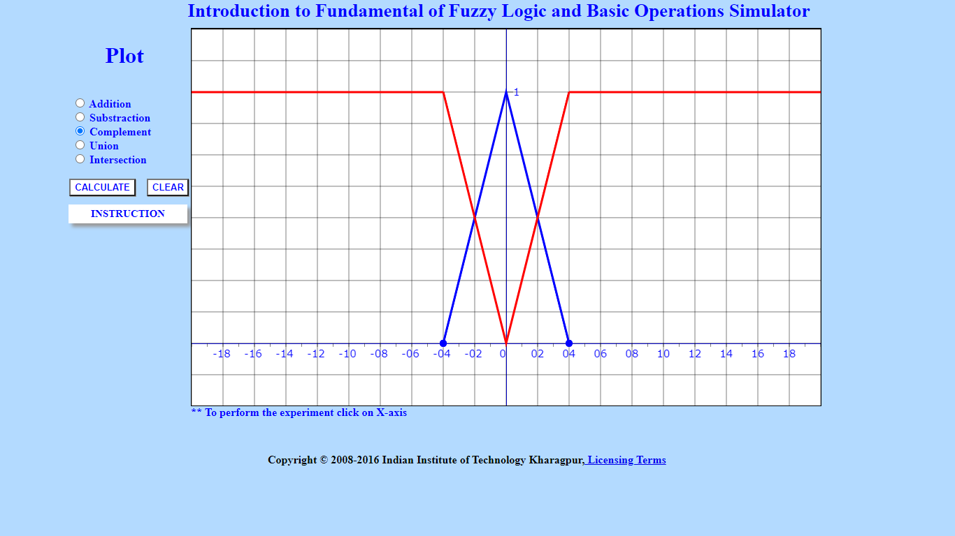

**Conclusion:** We have studied fundamentals of Fuzzy Logic and performed logical operations on the simulator.